The Future in a Vault of Plastic: Physical Geolocking in the Era of the 16-bit Video Game Cartridge, 1988-1993  
*Roland Burke*

C:\Users\T430s\Downloads\IMG_0001.tif

Fig. 1: Drawing the Borders: Detail of the original Sega Megadrive design schematic, with the assorted cartridge slot shapes indicated. Reproduced from Stuart and Wall, Sega Mega Drive/Genesis: Collected Works, n.p: Read Only Memory, 2014.

IP address geoblocking has been implemented to partition what would otherwise be potentially borderless worlds of information and entertainment delivered via the internet.[[1]](#footnote-1) Digital media markets, differentiated in price and access to different ‘regions’ of the globe, now provoke widespread circumvention. Perhaps unsurprisingly, the established hierarchy of digital citizenship has been contested most actively by the citizenry on its margins; particularly in Australia, a wealthy but remote country, with very rapid uptake of technology. Australia’s digital citizens, who are amongst the most privileged and prosperous in the physical world, have railed against their digital marginalization with an exceptional intensity.

This is, however, not a wholly new phenomenon. There is a long history of Australian consumers subverting the efforts of their electronic suzerains, not only in the United States, but also Japan, through unauthorised circumvention and parallel importation. Among the most dedicated consumers are Australian gamers, who have been manually modifying game cartridges meant for other markets for at least two decades. This chapter recovers some of that past, and points to a much longer tradition of citizen-led circumvention. It also seeks to restore, in a modest way, an aspect of digital entertainment that has been largely neglected; namely, the creation and circulation of digital information as a discrete physical entity.[[2]](#footnote-2)

## The Future Elsewhere: Japan’s revival of home video gaming

Video gaming, as a consumer past time, emerged in the United States. After a number of comparatively unsuccessful precursors, Atari inaugurated a popular culture boom in video games between 1978 and 1983. It was not to last, and after quality control concerns, and catastrophic market oversupply, this first video game efflorescence dramatically darkened, before a slow recovery in the mid to late 1980s.[[3]](#footnote-3) The epicentre of the revival of home video gaming was Japan, a market partially decoupled from the precipitous collapse of the US home gaming industry across 1982-84.[[4]](#footnote-4)  As the iconic brands of the preceding Atari age fell, not merely into hardship, but in many cases, bankruptcy, Japan was a kind of sanctuary site. This was where the new custodians of electronic entertainment, Nintendo and Sega, prospered - first at home, and, from late 1985, abroad.[[5]](#footnote-5)  Japanese gaming consoles repopulated a desolate American market, and conquered the PAL television system countries of Western Europe and Australia in turn. The Nintendo Entertainment System, and its counterpart, the Sega Master System, restored gaming to its more or less continuous trajectory of growth – a steady gradient which would advance video games to their current, ascendant, position as largest global media industry.

Regional lock-out mechanisms were largely absent from the consoles of the late 1970s and early 1980s. The Atari VCS, Mattel Intellivision, Milton-Bradley Vectrex, and Coleco Toys Colecovision contained no explicit regional locking provisions, though this was no absolute assurance of pan-regional compatibility. In the case of the Atari VCS, the first mass-market system with interchangeable game cartridges, the reality of highly constrained hardware mandated an effective, if inconsistent, region lock. The video display chip and CPU at the heart of the VCS were closely coupled to the raster output of the television: they literally ‘raced the beam’, or electron gun that painted the TV screen.[[6]](#footnote-6) It followed that the precise timing mattered, and thus, games needed to be finely calibrated for either NTSC (60Hz), or PAL (50Hz).[[7]](#footnote-7) It was a regional lock of sorts, reflecting the difficulty of making a functional, affordable video game system with mid-1970s integrated circuit technology.

In the mid-1980s, with the new Japanese consoles, the relationship between television system and console hardware was less intimate. Newer graphics chips were not so closely coupled to the raster of the television screen. More particularly, there was the emergence of regional coding created independent of television system. Japanese Nintendo games were regionally-locked to the Japanese Nintendo console (Famicom), preventing its cartridges being played on the American Nintendo.[[8]](#footnote-8) This was despite both systems being, in essence, fully compatible, and sharing a common NTSC television output. Nintendo redesigned the form factor of its cartridges to prevent their physical access to American systems, and, for good measure, rerouted the gold pins of the cartridge interface to a new, North American specific, pattern. With the advent of the first Nintendo, the region lock was now much more than a happy, market-segmenting accident derived from television standards – it was a conscious technological strategy crafted by the system vendor.[[9]](#footnote-9)

Between 1988 and 1993, the second wave of Japanese origin consoles, first from Sega in 1988 (Japan, 1990 US, 1991 EU/Australia), and later Nintendo (1990 Japan, 1991 US, 1992 EU/Australia) – arrived in the historically neglected PAL markets. This chapter willfocus on Australia, a geographically isolated region, with no land borders, and no proximate NTSC neighbour – and one which often lagged behind Japan and the United States, in terms of the release of both video game hardware and its requisite software. The second wave of the console contest was the crucible for the modern gaming market, when gaming began to escape to the living room, and to the adult world. With improvements in transistor density, increased global RAM supply after the catastrophic shortages of the late 1980s, and larger markets across which to amortize research and development, video games were markedly more accessible, sophisticated, and aesthetically impressive experiences.[[10]](#footnote-10) A fierce format war between Sega and Nintendo intensified competition, and accelerated the rate of innovation.[[11]](#footnote-11) In this new gaming environment of the 1990s, the issue of region locking became progressively more acute.

The Sega Megadrive was a revealing case. While provisioned with some capacity for an electronic lockout, the console’s key region-locking mechanism was a simple variation in the geometry of the cartridge slot.[[12]](#footnote-12) In other words, for much of the Megadrive’s commercial life geographic market segmentation was achieved solely by this decidedly flimsy physical countermeasure.

Most cartridges released for the system, and almost all of the most popular titles, would play without incident on both NTSC units, those from Japan and the United States. They would also play on PAL systems, provided they could be inserted into them. As a result, the barrier to importing games was vastly diminished. There was no requirement to purchase a Japanese or American console, a voltage transformer, or a still highly esoteric multi-color system television. In many cases, region-specific languages were also included on the same cartridge, precluding the need for any local language translation for instance, from Japanese to English – a need which was already modest given the comparative narrative simplicity that defined the games of this period.[[13]](#footnote-13) The Megadrive was a rare case where physical blockade was the prime means for seeking a market segmentation; a segmentation that always tended to disfavor the PAL regions of Europe and Australia. Predictably, the unsophistication of the geometrical ‘lock out’ was rapidly exploited by Australians.

## Breeching the Polypropylene Wall: Console Hacking with a Hacksaw and a Heated Carving Knife

Demand for Japanese cartridges in Australia was driven by the long delay between releases in Japan, and those in the PAL countries.  In the late 1980s and early 1990s this delay typically amounted to a full fiscal quarter, and often extended to an entire calendar year. Holding back the flood of eager video gamers was, remarkably, a small piece of plastic, which altered the geometry of the cartridge slot – with Japanese cartridges shaped slightly more widely than the slots present on the PAL Megadrive console units.  The difference which prevented their use in the Megadrive machines of Britain and Australia, around 12mm, was breathtakingly – perhaps heartbreakingly – close.[[14]](#footnote-14) In essence, slightly more than a centimetre of matte black polypropylene was assigned the weight of defending Australia’s cultural borders, or perhaps more accurately, allowing market segmentation by the Japanese parent and its subsidiary. Unremarkably, it was a barrier soon breached by enterprising children, and nervous adults who looked on in fear as their young performed makeshift surgery on the casing of the expensive Megadrive hardware, or provisioned substantial sums of cash to purchase grey market adaptors for the rival console, the Super Nintendo, from dog-eared mail order forms.

For the Megadrive, the process was elegant in concept, and alarming in practice. The outer shell of the cartridge slot, the final sentinel against imported software, had two small tabs of plastic excised. Due care was required that the chosen implement, typically a heated carving knife (for clean margins on the incision), or an electric variant, did not make contact with the motherboard that resided beneath. With these thermoset plastic border posts removed, by a doubtlessly tremulous pair of hands, all cartridges could be inserted without impediment. Marginally more sophisticated was the procedure for the Megadrive’s rival, the Super Nintendo. A very crude region checking system had been implemented; but one easily deceived by replicating the cartridge slot. An aftermarket adaptor would accommodate one ‘native’ region cartridge for chaperone duties (almost always *Super Mario World*), which would present its endogenous credentials; and then immediately defer to the ‘foreign’ cartridge that was mounted in tandem in the replicated slot alongside it. For the Sega system, circumvention involved punching a hole in the geo-fence; for the Super Nintendo, it required a ‘native’ regional escort providing a fleeting moment of diplomatic cover. In both cases, the breech was easily and cheaply made.

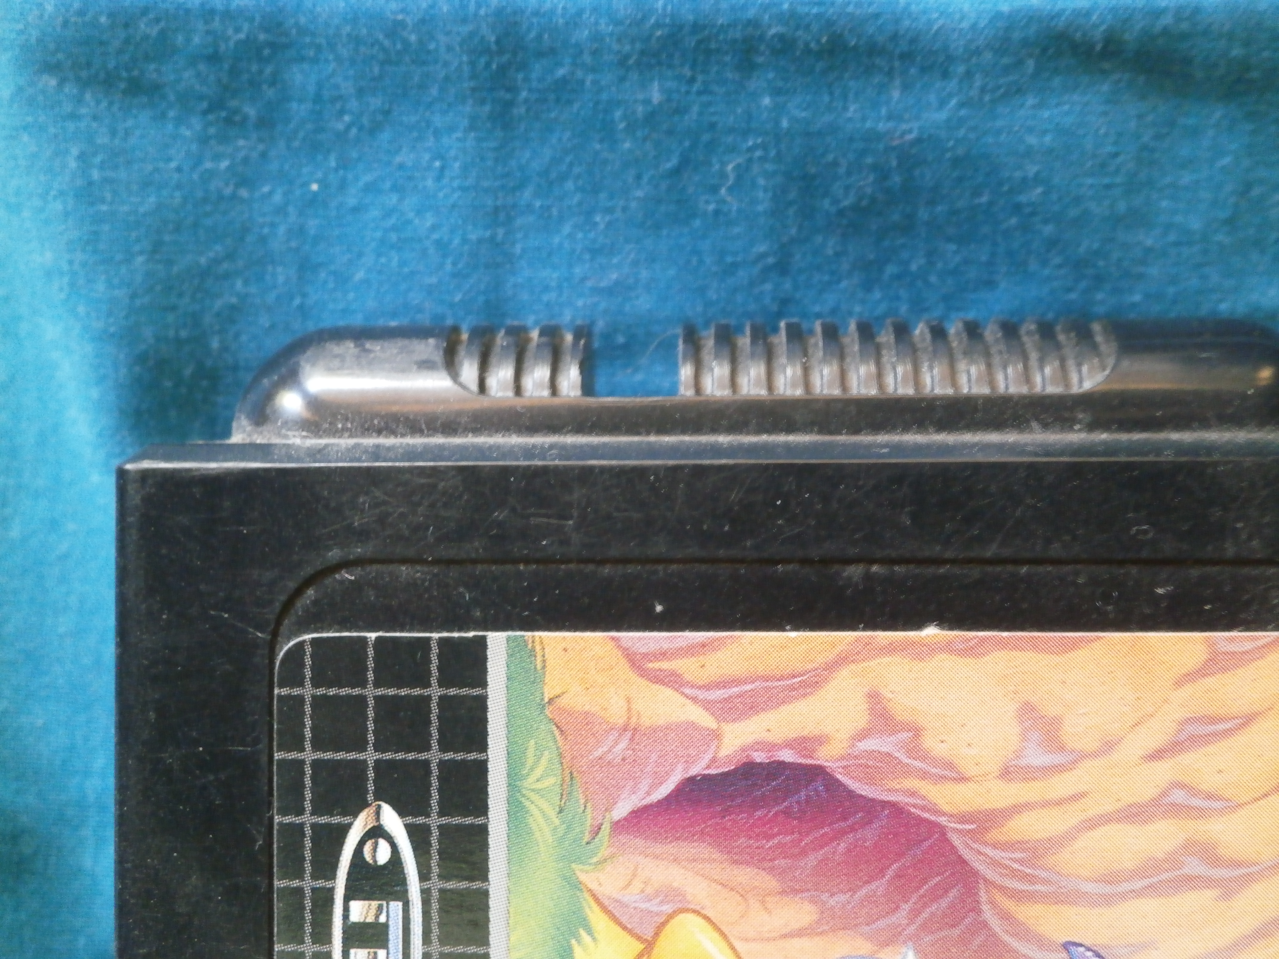

Figure 2. The Japanese Megadrive cartridge with its infuriating rounded edge. The owner is mere millimetres away from fun. Image: Roland Burke.

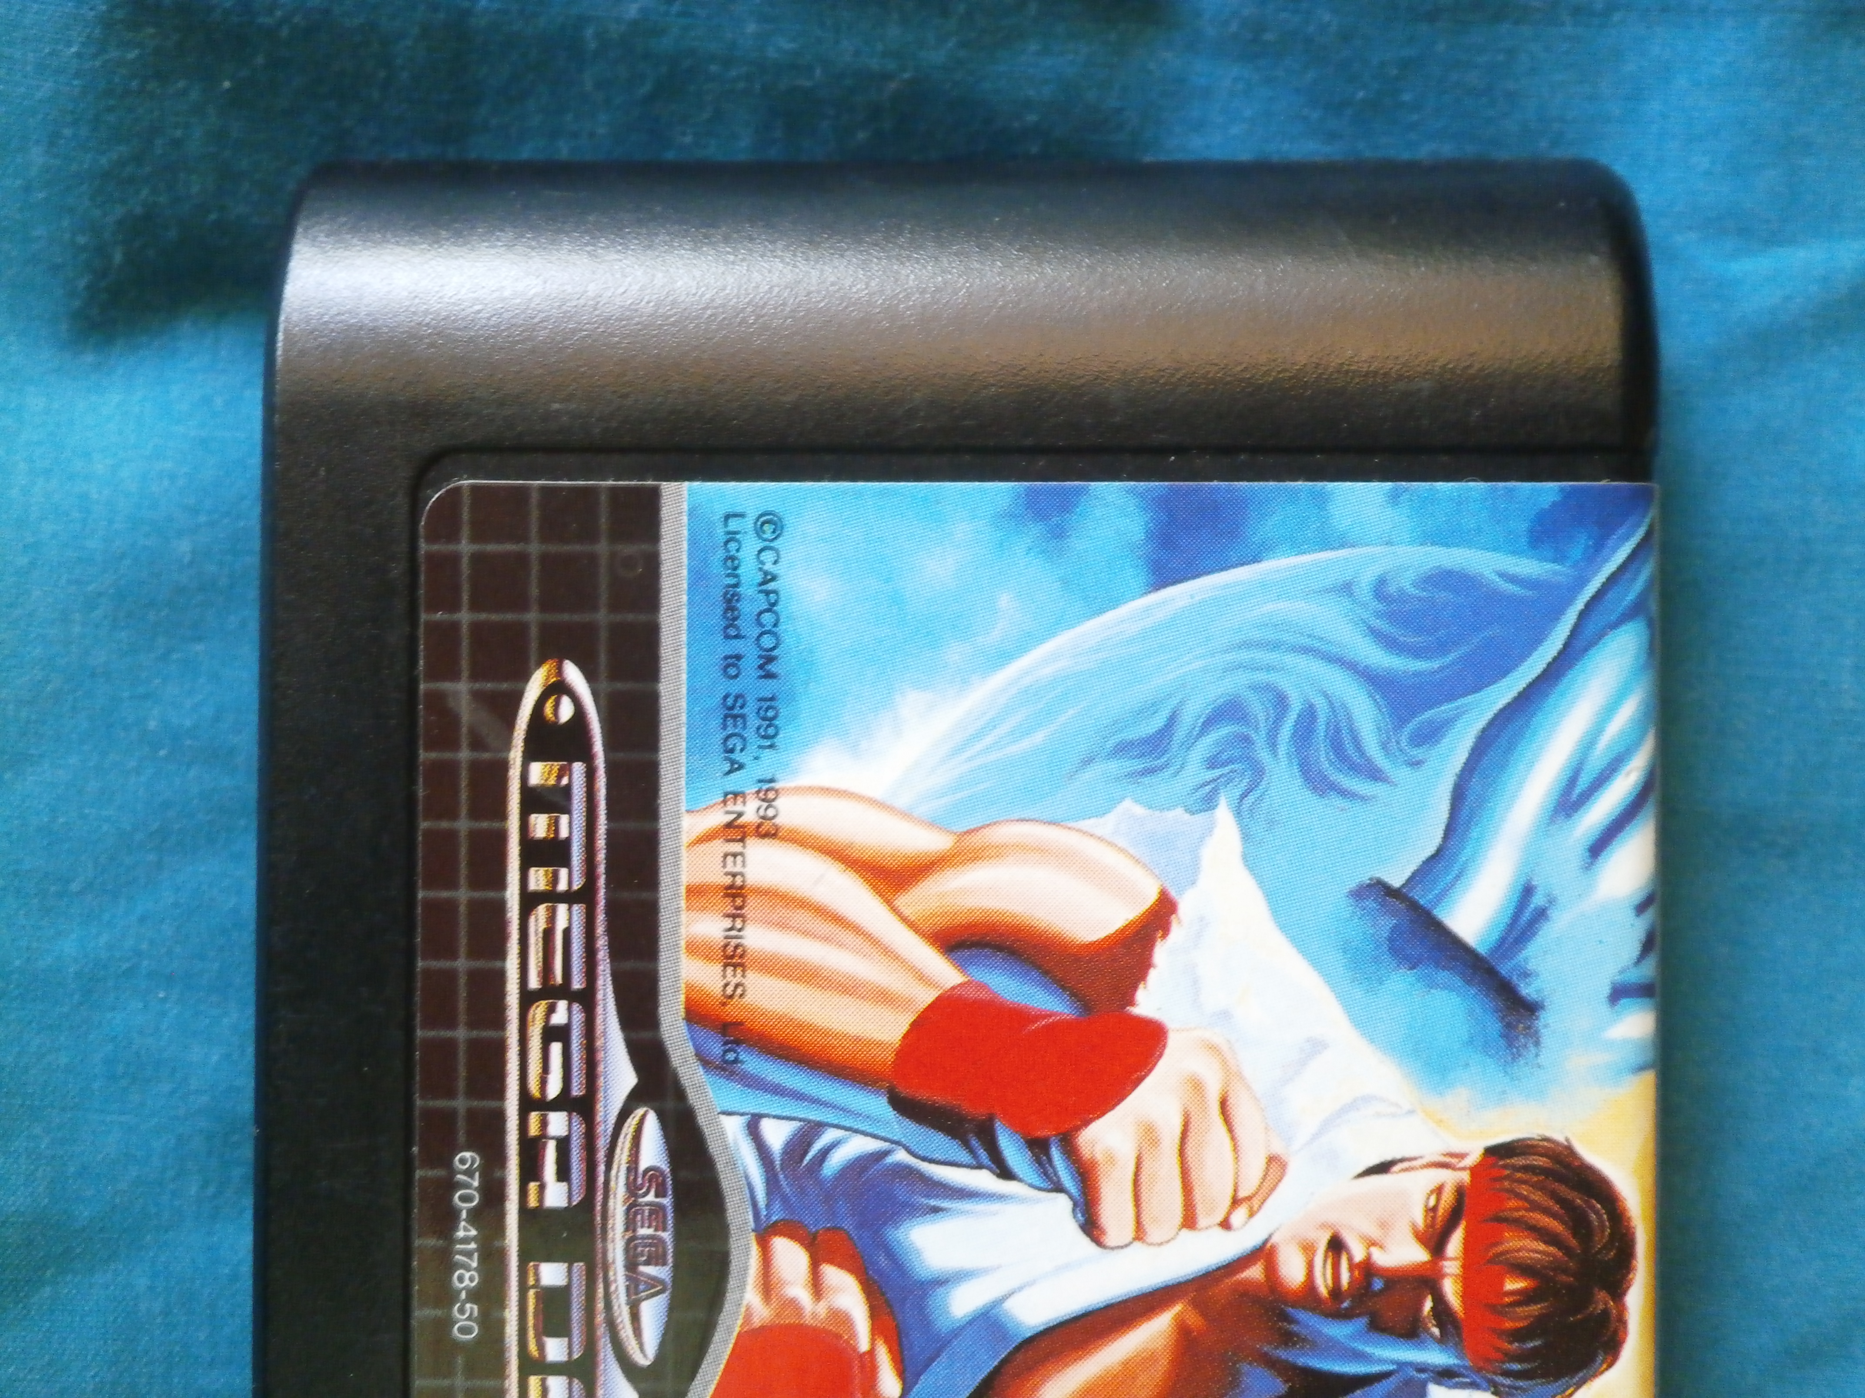

Figure : The localized Australian Megadrive cartridge, with its distinctive curved spline. Image: Roland Burke.

Circumvention was not a procedure undertaken without considerable deliberation and forethought. Inexperienced hands, no matter how nimble, could fatally damage the Megadrive, which was, at the time, an extortionately priced piece of consumer electronics, with a price tag of A$399 in 1991. Acquiring the console required studious petitioning and parental patronage, and even then, the cost involved made it the preserve of the middle class.[[15]](#footnote-15) With Australia entering a very steep and prolonged economic recession shortly after the release of the Megadrive, it tookyears of depreciationand improving economic conditionsbefore it arrived at a mass market price Breaching the cartridge slot, and thus reaching the ‘future’ (actually the geographically distant present), was an enterprise that involved great risk. Physical puncture of the motherboard, or electrostatic discharge, could permanently destroy a comparatively massive capital outlay. Australians could leap to the future of Japanese games, but the penalty for a failed attempt would be severe.

## Visible Public Networks: The Classroom VPNs of the early 1990s and the Prestige of Gaming Scarcity

As video game journalism matured during the 1990s, popular knowledge of circumvention increased. Until this point, this gap between promised excitement and local disappointment was present, but manageable.  The latency between knowledge of new overseas games, as revealed in effusive print reviews and colorful screenshots, was modest.  Almost all dedicated English-language video game journalism was published in the UK or the US.[[16]](#footnote-16)  Delivered via the most economical tier of surface mail, the journey of the magazines -- the paper vectors for anticipation, excitement, and, usually, frustration -- consumed much of the latency period between knowledge and release.  The games arrived much later than they did in Japan or the United States, but so too did the knowledge of their existence, or in the case of reviews, the assurance of their hedonic virtue.

In the 1990s, this slothful symmetry between printed gaming magazine and printed circuit board was radically disrupted; not by the internet, which remained a mostly inaccessible, text-based curiosity, but by the advent of widespread air mail distribution. Initially confined to hyper-specialist outlets, most famously McGill’s Bookshop in Elizabeth Street, Melbourne, the air mailed gaming magazine delivered the future (geographically quarantined present), to the Australian suburbs. There was a substantial price premium, with air-mailed issues almost double the price (A$8.95to A$4.95), but air mail proliferated, particularly through Pacific Computers, a specialist gaming vendor that rapidly spread across suburban malls in southern Australia. Perhaps appropriately, the air-mailed titles had their own informational lock out. They were almost always sealed in plastic -- presumably a measure of prophylaxis against physical damage, but also, a physical membrane which foreclosed access to the knowledge within prior to purchase. This was special, and expensive information. Purchasing a quantum of it was a major outlay – one typically recouped in social capital when latest magazine was circulated by its proud owner amongst school friends.

Beyond the circulation of expensive magazine knowledge, the ownership of highly anticipated games, well in advance of their domestic launch dates, lent social and cultural capital within school environments, typically amongst late primary and early secondary boys. During the early 1990s, in middle- and upper-middle class suburbs, where almost every want or vaguely expressed material desire could be, and often was, fulfilled, the special supra-monetary value of having an ‘import’ was a socially advantageous asset. Study of the glossy printed materials, which were richly illustrated, and the even the packaging, were privileges to be disbursed judiciously over a playground lunchtime. Indecipherable Kanji characters added an exoticism – though presumably few pondered the sources of the mystique that a Japanese game held. Parsimony in access not merely to the game, but to the material artefacts of the game cartridge, preserved its scarcity. Custodianship of a high-profile imported game, be it *Strider,* *Bare Knuckle*, or most especially, *Street Fighter 2* was a solemn responsibility – albeit one typically wielded with the glib caprice and irresponsibility that inhered in schoolyard politics and classroom diplomacy.

It followed that pricing was not, in the main, driving demand for Japanese or American releases. Very often, imported games, especially highly anticipated titles, were more expensive at import than their domestic siblings would be at their official launch. In July 1992, *Street Fighter 2* for the Super Nintendo sold for A$140 as an import, with an additional A$50 for the requisite cartridge adaptor.[[17]](#footnote-17) But it was available – and available at exactly the moment that voluminous reviews, each with praise more superlative than the last, arrived in air-mail imported magazines. The transaction, in the most fundamental form of exchange, repartitioned money into time – time with the game, and in a stroke of serendipity, time which coincided with the two week winter recess in Australian primary schools.[[18]](#footnote-18)

## Conclusion: Unlocking the Plastic Gates of the Future

The physical geo-lock of the 16-bit gaming era was an admixture of the then high-tech Motorola 68000 CPU, and ultra-high performance pseudo-SRAM chips, and the decidedly low technology of injection moulding. Its very lack of sophistication marked it out as a profoundly different, and strangely democratized, cultural milieu. Hierarchies were based on depth of enthusiasm; whereby ownership of a prized Japanese title was demonstrative not of greater funds (though plenty were still needed – and always remained insufficient), or of ultra-specialist technical skill, but of daring, and of being privy to seemingly special personal networks. The later era of circumvention, which arrived with optical disk based consoles, notably the Sony Playstation (1995) and the Sega Saturn (1995), altered this arrangement. With the implementation of a digital lockout, the barriers to circumvention were raised dramatically. Bypassing this new generation of software-based geo-locking required custom-made integrated circuits. The energetic resourcefulness of young adults was no longer adequate; and the cross-over with flat out illegality, insofar as the same anti-geolock chips allowed piracy, loomed.

Equally, the 16-bit age represented a more restrained era in the vendor-consumer arms race, a race which has often produced mutually assured irritation. The Megadrive’s unsophisticated physical lock allowed owners a degree of autonomy over their machines – and the constraints on import were mostly those of logistical inconvenience. Enthusiasm and desire could overcome these obstacles, but would only ever do so for a limited market segment, and thus placed an upper ceiling on disruption to local distribution channels and market control. Legislative responses, insofar as they existed, were confined to the sporadic and well-publicized confiscation of imported games by Australian Customs (promptly and ostentatiously donated to local children’s hospitals), an enforcement measure which was abandoned in the wave of competition reforms which relaxed parallel import rules. Even the expansive, omnibus anti-circumvention provisions of the Digital Agenda Bill (2001) would seem ill-armed to counter the threat of a kitchen knife and a determined young video game enthusiast with a poorly developed sense of risk.

The five prime years of the 16-bit video game console also represented a liminal moment in electronic entertainment. Dissemination of information was, emphatically, still physical. News of video games arrived in magazines – initially with considerable delay. The games themselves, although digital, were housed in gaudy plastic carapaces. These cartridge shells protected their contents from static electricity and water (cola) – and, in their territory-specific geometry, sought to prevent their migration from East to West. It was also the last generation where gaming was dominated by the de facto duopoly of Nintendo and Sega, companies with a strong heritage in physical entertainment products. Unlike Sony, which had a large portion of its enterprise tied in the ethereal intellectual property of music rights and film, or Microsoft, which joined the console ‘wars’ in 2001 having previously been a software company, Nintendo and Sega were experts in producing entertainment objects.

The temptation for Nintendo to approach the new world of software with a vestigial attachment to the physical and material was surely powerful.[[19]](#footnote-19) The Nintendo 64 (June 1996 Japan, September 1996 US, March 1997 Australia/Europe) utilized cartridges, years after its competitors had migrated to optical disks, and despite the complaints of software developers. Nintendo clearly had yet to be persuaded that the delivery medium did not matter. The incredibly high quality of the N64 software library, its resistance to commercial piracy, and the elevated value of these cartridges on the secondary market suggests there was some merit in Nintendo’s caution in embracing fully commoditized data formats like optical disc.[[20]](#footnote-20)

The schoolyard circumvention movement of the early 1990s was a fleeting one, and while it presaged aspects of the future – notably, the dramatic rise of the global video game market -- it probably resided more in the last act of a past where entertainment media was unambiguously embodied in a tactile object. The world of the Sega Megadrive and the Super Nintendo consoles marked the zenith in the cartridge as a material entity; with designs which had become, by the early 1990s, truly Baroque. During the last years of cartridge distribution, there were perceptible differences in weight – with the most recent and advanced titles markedly heavier, owing to a denser array of ROM chips, which held the game program.[[21]](#footnote-21) With ROM chips relatively expensive, in this terminal phase of cartridge distribution, gaming data was being purchased by the gram.

With the rise of the Playstation in the mid-1990s, the long decline into digital weightlessness had begun. Optical disks varied little in appearance, the same in form factor as the audio CD. Discs were a fully commoditized and disappointingly insubstantial medium – pressed at will from polycarbonate and aluminium, and holding only cents worth of intrinsic value, which clung desperately to the optical platter, only tens microns of ill-handling away from an unrecoverable scratch. The ever-increasing abstraction of the game from its medium of delivery, arguably heightened dissatisfaction with any delay in it reaching a PAL market Gone was the material dimension of the cartridge; a proprietary format, not interchangeable with mass market optical disks, and with a distinctive design and aesthetic of its own.

There was, by the end of the first Playstation age in the late 1990s, no more mystique about the physicality of gaming software. Interest in the game software as an object rapidly became confined to the arcane antiquarianism of retro-video game collectors.[[22]](#footnote-22)

Geometry lockout had matched, for a short moment, a hybrid digital world, where information was digital, but had to be affixed to ROM chips for its survival and global dissemination. It travelled in bulk container ships and 747 cargo conversion holds, and was restricted by the costs of commercial shipping, not arbitrarily emplaced IP block ranges. Its encryption was a geometrical puzzle; an alteration in cartridge shape, and no more. At the time of the 16-bit consoles, especially the Megadrive, geo-locking was a spatial exercise – and its resolution could be found in spatial ingenuity. For those passionate enough to husband the safe travel of those bits through the geographic space of Japan to Australia, and to pilot the delicate final leg, through the micro-geographic shoals of occluded cartridge slot to unshielded cartridge port, the impediments imposed were merely those of the real geo-, not the stratified one prescribed by corporate entities.

1. See, for instance, Michael Strangelove, *Post-TV: Piracy, Cord-Cutting, and the Future of Television,* Toronto: University of Toronto Press,2015; Brett Christophers, ‘Spaces of Media Capital’, in Paul Adams et al. (eds), *The Ashgate Research Companion to Media Geography,* Surrey: Ashgate, 2014, 363-376; and Christophers, *Envisioning Media Power: On Capital and the Geographies of Television,* Plymouth: Lexington, 2009. See also the sibling work on parallel, semi-subaltern, circumvention networks, physical and electronic, notably from Ramon Lobato, *Shadow Economies of Cinema: Mapping Informal Film Distribution*, London: Palgrave, 2012; and the large scale survey works from Adrian Johns, *Piracy: The Intellectual Property Wars from Gutenberg to Gates,* Chicago: University of Chicago Press, 2011; Patrick Bukart, *Pirate Politics: The New Information Policy Contests,* Cambridge, MA: MIT Press, 2014; and Hector Postigo, *The Digital Rights Movement: The Role of Technology in Subverting Digital Copyright,* Cambridge, MA: MIT Press, 2012. [↑](#footnote-ref-1)
2. The historical milieu of video games, and the labor process by which they were created, produced, and disseminated, has not yet received substantial scholarly investigation. The specialist periodical *Retrogamer* (Imagine) has produced some excellent episodic coverage and interview material, as has the recent work from Keith Stuart and Darren Wall,devoted solely to the Megadrive, with historical drawings, and interviews ranging from its lead software engineers, to the industrial designer who sculpted its casing. See Stuart and Wall, *Sega Mega Drive/Genesis: Collected Works,* n.p: Read Only Memory, 2014. Much of the investigation to date has been focused on the neo-Romantic period of British home computer video games, with recent studies from Christopher Witkins, *The Story of the Sinclair ZX Spectrum in Pixels*, n.p., Fusion Retro Books, 2014; and *The History of Ocean Software,* n.p., Fusion Retro Books, 2014, and a forthcoming book on software publisher US Gold (2015). Given its centrality to the birth of gaming, Atari has been the subject of some extensive historical coverage on labor environment and workplace culture, with a voluminous and insightful empirical account furnished by Curt Vendel and Marty Goldberg, *Atari Inc.: Business is Fun*, Carmel, NY: Syzygy Press, 2012. There appears to be a growing interest in Japan’s historical video game production environment, though current work is confined to S.M.G Szczepaniak, *The Untold History of Japanese Game Developers*, n.s., 2014. [↑](#footnote-ref-2)
3. This story is detailed in numerous narrative histories, see Tristan Donovan, *Replay: The History of Video Games Paperback*, East Sussex: Yellow Ant, 2010; Steven Kent, *The Ultimate History of Video Games: From Pong to Pokemon: The Story Behind the Craze That Touched Our Lives and Changed the World,* New York: Three Rivers, 2001; Mark Wolf, *The Video Game Explosion: A History from Pong to PlayStation and Beyond*, Westport: Greenwood, 2007. See also the dedicated studies of this foundational period, Mark Wolf, Jessica Aldred, Ralph Baer et al., *Before the Crash: Early Video Game History*, Detroit: Wayne State University Press, 2012; Roberto Dillon, *The Golden Age of Video Games: The Birth of a Multibillion Dollar Industry*, Boca Raton, FL: Taylor & Francis, 2011; see especially, the volume from Ralph Baer, inventor of the television game, *Videogames: In the Beginning*, Springfield, NJ:  Rolenta, 2005. [↑](#footnote-ref-3)
4. This Japanese revival is a central waypoint in the periodization of video game history, by near universal consensus across all of the major survey works, see for instance, Chris Kohler, *Power-Up: How Japanese Video Games Gave the World an Extra Life,* Indianapolis, IN: Brady Games,2004; Leonard Herman, *Phoenix: The Fall & Rise of Video Games*, Springfield, NJ: Rolenta, 1997. [↑](#footnote-ref-4)
5. Jeff Ryan, *Super Mario: How Nintendo Conquered America*, London: Penguin, 2012; David Sheff and Andy Eddy, *Game Over Press Start To Continue*, Wilton, CT: Cyberactive Press, 1999. [↑](#footnote-ref-5)
6. For an outstanding study of the VCS, and the relationship between material, technological constraint and gameplay, see Nick Montfort, *Racing the Beam: The Atari Video Computer System*, Cambridge, MA: MIT Press, 2009. [↑](#footnote-ref-6)
7. The differences between PAL and NTSC have been exhaustively parsed, see, for instance, Jim Slater, *Modern Television Systems*, London: CRC Press / Longman, 1991, 1-55; see also Megumi Ogawa, *Protection of Broadcasters’ Rights***,** Leiden: Brill, 2006, 55. [↑](#footnote-ref-7)
8. For the most detailed empirical study of the origins, and broader impact, of the original Nintendo, see Nathan Altice**,** *I Am Error: The Nintendo Family Computer / Entertainment System Platform*, Cambridge, MA: MIT Press, 2015**.**  [↑](#footnote-ref-8)
9. This was a strategy continued by Nintendo’s rival, NEC, which re-badged its popular Japanese console, the PC-Engine, to the Turbografx-16 for US sale. The Turbografx, which had a different plastic shell, and a larger form factor, had its card-shaped cartridges region locked between Japan and the US via differences in the interface pins which connected game to console. The PC-Engine/Turbografx did not receive a PAL territory release, though one was planned, and some inventory prepared for Western Europe. [↑](#footnote-ref-9)
10. For the state of the relevant segments of semiconductor industry in the latter 1980s, see Dataquest, ‘Report on Asian Semiconductor and Electronic Technology Service (1991)’, available at http://archive.computerhistory.org/resources/access/text/2013/04/102723217-05-01-acc.pdf. [↑](#footnote-ref-10)
11. The early 1990s ‘Console War’ was regarded as something of a revolutionary period in gaming development, see generally, Blake Harris, *Console Wars: Sega, Nintendo, and the Battle that Defined a Generation*, New York: HarperCollins, 2014; and Sam Pettus et al., *Service Games: The Rise and Fall of SEGA: Enhanced Edition*, Seattle: CreateSpace, 2013. [↑](#footnote-ref-11)
12. The origins of the Megadrive's lockout policy were within management at Sega Japan, which held an almost imperial control over its regional subsidiaries, including the vast American market. Former director of Sega's US branch, Michael Katz, who presided over a considerable sales success in North America, noted that 'lockout decisions were made in Japan. The Sega Japan International VP handled international sales  and marketing'. Sega Japan's reasoning was explicitly designed to foreclose the operation of a flat internationalized market, with its former chief of public relations stating frankly that 'we implemented the security regionally to prevent game software being imported due to gaps of sales time between regions'. Quote reproduced in 'The Megadrive', in *The Videogames Hardware Handbook, Volume 2*, Willenhall:  William Gibbons and Imagine Publishing, 2015,  21. [↑](#footnote-ref-12)
13. Speculatively, this may well have been to mitigate against the inventory risk that inhered to the cartridge format. As a write once, never erase medium for software, the Mask ROM chips which contained the software presented an immense risk to software publishers. An order of too few cartridges could produce unrecoverable shortages for key sales periods, such as the Northern Hemisphere winter; a situation which would take months to remedy given the austere limits on Mask ROM production. Conversely, too many units, and the risk of unsold, and expensive, stock, could obliterate any prospect of profit. By consolidating in a central inventory, only the external casing of the cartridge and packaging, manuals, and ephemera – all inexpensive, low lead-time items, needed to be altered to match product to diverse markets. [↑](#footnote-ref-13)
14. A number of later revisions to the Sega Megadrive did have some software based lock-out mechanisms, which operated alongside anti-counterfeit protection, though it was very inconsistently applied. See *Electronic Gaming Monthly,* September 1992, 76. [↑](#footnote-ref-14)
15. Putting aside the steady stream of game cartridges that would invariably be sought after the Sega Megadrive itself had been secured, at 399AUD, the console outlay alone represented a massive fraction of Australian adult average weekly earnings before tax, which stood at 568AUD in August 1991. See Australian Bureau of Statistics, Report on Average Weekly Earnings, August 1991, released 19 December 1991, available at http://www.ausstats.abs.gov.au/ausstats/free.nsf/0/FAE37DAF57F82D9DCA2574FA00184F33/$File/63020\_AUG1991.pdf. [↑](#footnote-ref-15)
16. EMAP Images, publishers of *Computer and Video Games*, and from late 1989, the console focussed sibling, *Mean Machines*, were the most widely distributed in Australian newsagents. Prevalent, but slightly less common, were the American *Electronic Gaming Monthly* (available in Australia in very early 1990), and *Gamepro*. [↑](#footnote-ref-16)
17. Part of this expense derived from the generous amount of ROM employed to deliver a reasonably faithful reproduction of original arcade game, which had been wildly successful. The home version used 16Mbit of ROM (2Mbyte), twice that of other premium Super Nintendo titles. American reporting prior to launch emphasized this vast reservoir of ROM, with a large photograph of the cartridge with its top shell removed, and banks of ROM chips visible on the circuit board. See *Electronic Gaming Monthly* (April 1992), 42. [↑](#footnote-ref-17)
18. 1992, *Trinity Grammar School Diary*. [↑](#footnote-ref-18)
19. For Nintendo’s longer genealogy, see the two volumes from Gorges et al. *The History of Nintendo 1889-1980* and *The History of Nintendo 1980-1991*, Triel-sur-Seine, France; London: Les Editions Pix'N Love, 2012. [↑](#footnote-ref-19)
20. Nintendo was perhaps the most extreme example of physical locking, taking countermeasures even against mechanical access to the hardware. After initially using standard Philips head screws to assemble its console, it later migrated to a proprietary screw head for the outer screws which held the console’s case together. These special Nintendo ‘Gamebit’ screws required a Nintendo screwdriver to release – a screwdriver that was not available on the general market. In the absence of the screws, access to the inside of the Nintendo 64, for example, required the destruction of the screws with a power drill. [↑](#footnote-ref-20)
21. For a précis of ROM technology, its characteristics, and evolution over time, see note at Computer History Museum, ‘Semiconductor Read-Only-Memory Chips Appear’, available at http://www.computerhistory.org/semiconductor/timeline/1965-ROM.html; for further detail, see University of Michigan, ‘ROM, EPROM, EEPROM’, https://web.eecs.umich.edu/~prabal/teaching/eecs373-f10/readings/rom-eprom-eeprom-technology.pdf; Smithsonian Institution, ‘The MOS Memory Market (1996)’, available at http://smithsonianchips.si.edu/ice/cd/MEM96/SEC01.pdf. [↑](#footnote-ref-21)
22. The materiality of games and their conservation has only recently begun to emerge as a topic of academic inquiry, see notably Raiford Guins, *Game After: A Cultural Study of Video Game Afterlife*, Cambridge, MA: MIT Press, 2014. [↑](#footnote-ref-22)